**Poisson blending results**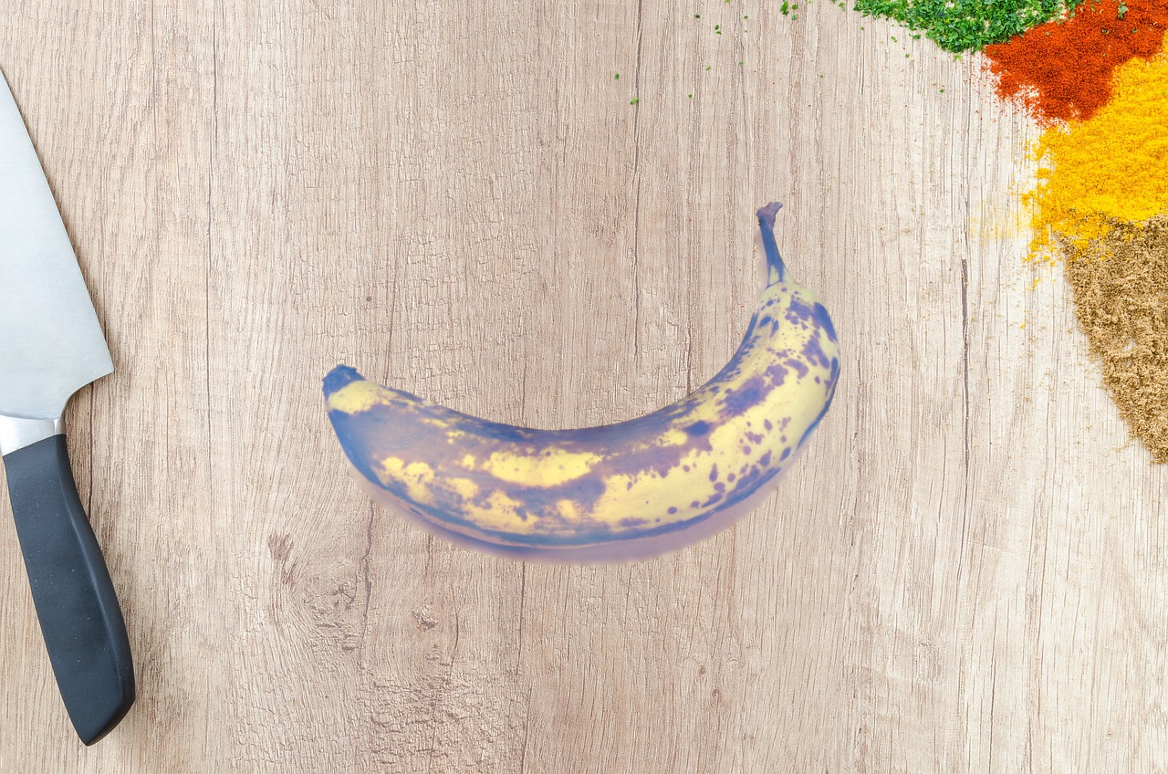

**Banana1 with table:**

The banana is blended well with the table background. The tight mask ensures that the edges of the banana are smooth and integrate seamlessly with the background, creating a realistic composite image.

**Flower with Grass Mountains:**

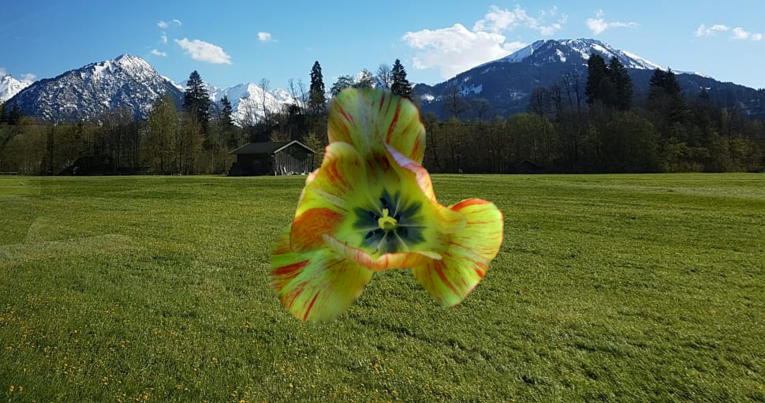

The flower integrates naturally with the grass mountains background, with intricate details captured by the tight mask, resulting in a smooth and realistic blend.

**2 examples of Non Tight:**

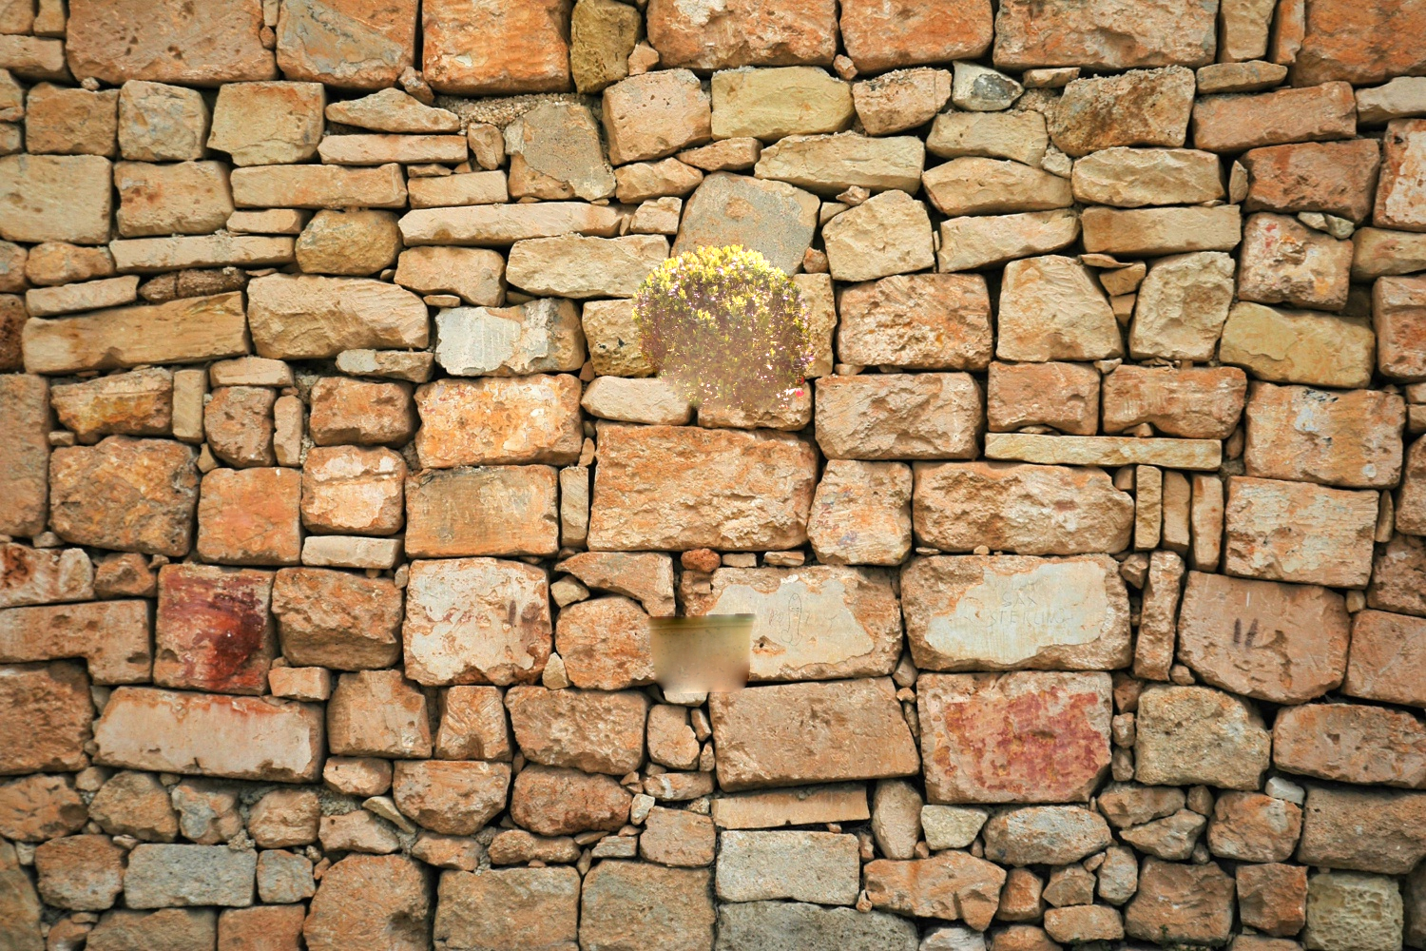

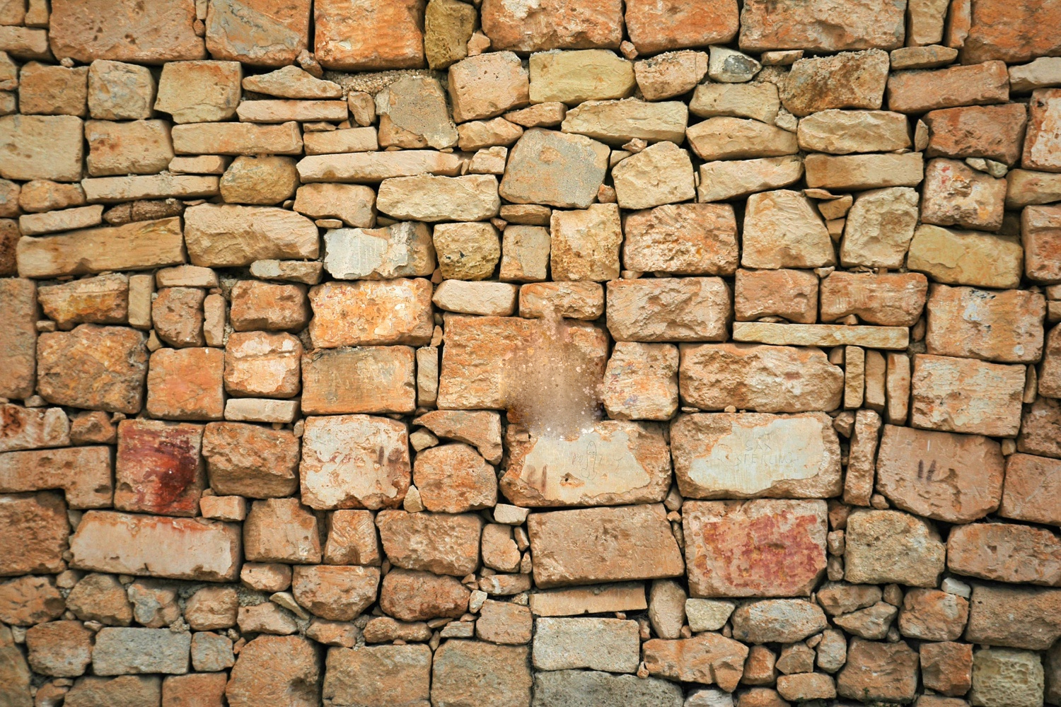

Both the bush and the grave exhibit blurred and poorly defined edges against the wall background. The non-tight masks cause inaccurate blends, making the objects appear less natural and less cohesive with the wall. The loose masks result in less defined edges, making the objects look unrealistic and poorly integrated